FREQUENTLY ASKED QUESTIONS
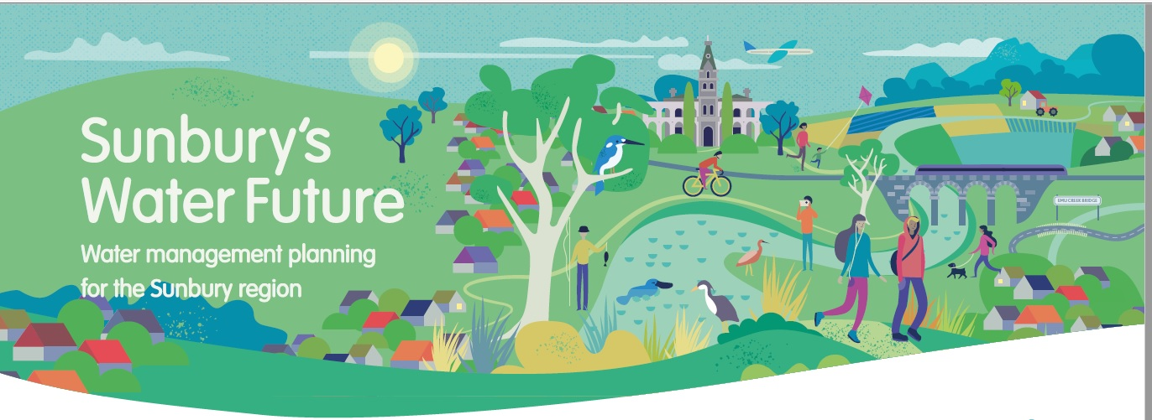
- Why is Sunbury’s Water Future happening?
Over the next 20 years, the population of Sunbury is expected to more than double in size, significantly impacting on Sunbury’s water supplies, wastewater management and local waterways like Jacksons and Emu Creeks.
The Sunbury region is largely reliant on drinking water supplies from outside the region. With limited harvest from local water catchments, reduced rainfall and its growing population, interventions are required to limit cost and environmental impacts and secure water supply for Sunbury into the future.
- Who is developing and rolling out the project?
Greater Western Water and Melbourne Water are working together to develop and deliver this plan. Melbourne Water and Greater Western Water manage different aspects of the urban water cycle.
​Melbourne Water is the supplier of bulk water and sewerage services to Greater Western Water, which then provides direct water, sewerage and recycled water services to Sunbury and surrounding towns. GWW’s full service region extends from the Melbourne CBD to Bacchus Marsh in the west and Lancefield in the north.
​Locally, Melbourne Water is also responsible for managing waterways, Jacksons Creek and Emu Creek, and providing drainage and flood management services for the area.
The project is being delivered in close consultation with key partners, including Department of Environment, Land, Water and Planning (DELWP) and Hume City Council.

- What has happened so far on the project?
Engagement for Sunbury’s Water Future began in September 2018 with a survey and targeted community discussions and workshops. ​
A community panel was formed in May 2019 and delivered a report detailing nine recommendations for the project in June of that year. Melbourne Water and Western Water (now Greater Western Water) published a response report in October 2019 endorsing all of the panel recommendations.
The community panel recommendations have informed the water management options being taken to a broader sample of the local community for consideration in this current phase of engagement.
Findings from the current survey will be used to inform future community engagement as the plan for Sunbury’s Water Future is developed.
- How have the community panel recommendations been used?
The panel recommendations will help to shape a water management plan for Sunbury that is effective, sustainable, and fit for purpose.
Since receiving the panel recommendations, we have:
- Used them as a basis to explore how water management options like recycled water and stormwater might be used in Sunbury and surrounds, and
- Consulted them when determining what future research and engagement should look like for this project.
- Now, we are testing the Panel recommendations with more people from the Sunbury and Macedon Ranges regions to understand more broadly how the local community feel about options for Sunbury’s Water Future.

- When will the project be finished?
The project aims to achieve final endorsement and approval from the Melbourne Water and Greater Western Water Boards in 2024.
- What is Integrated Water Management (IWM)?
Integrated Water Management (IWM) is a collaborative approach to the way we plan and manage all elements of the water cycle .
This includes making use of alternative water sources – like recycled water and stormwater – to reduce pressure on our drinking water supplies while protecting the health of our waterways. It brings together the many stakeholders involved in the water cycle.
This innovative approach allows us to integrate the water cycle with other aspects of urban management, such as land use planning and urban design, when undertaking planning and decision making. The IWM process also considers the environmental, economic and social impacts and benefits of different water management options. Using an IWM approach allows us to look at how the wider opportunities enabled by solutions such as alternative water can benefit communities like Sunbury.
- What is the difference between stormwater, wastewater, recycled water and alternative water?
Rainfall that runs off roofs, roads, footpaths and other hard surfaces is called ‘stormwater’. It’s collected in our stormwater drainage system where it’s sent to nearby rivers and creeks. It then eventually ends up in Port Phillip Bay.
Water that’s been used in the home, in a business or an industrial process is called ‘wastewater’. It travels through sewer pipes to wastewater treatment plants for treatment. For the Sunbury region, wastewater is transported to the Sunbury Recycled Water Plant. ​
When wastewater goes through a treatment process, it becomes ‘recycled water’ that can be reused for other purposes. The Sunbury Recycled Water Plant is one of seven recycled water plants operated by Greater Western Water.​ The recycled water from the Sunbury Plant is treated to Class B, some is used locally for irrigation and the balance is discharged to Jacksons Creek under a licence with the Environment Protection Authority. Recycled water treated to Class B standard is not suitable for drinking.
Alternative water includes treated stormwater and recycled water. These water sources can be treated to suit specific non-drinking and drinking end uses. Using alternative water sources may provide greater overall benefits for water conservation and the environment.
- What sources of water currently supply Sunbury?
Sunbury is typically supplied with water from the Melbourne supply system. This system consists of a number of reservoirs across the state as well as water from the Victorian desalination plant. Currently no alternative sources of water are used to meet Sunbury’s water demands.

