Community bulletin

Hadfield Park Wallan Creek naturalisation

# June 2021

# Melbourne Water is committed to enhancing life and liveability in your area. To maintain our assets, as well as improving the natural amenity and liveability of the area, we will soon be undertaking works to naturalise a section of Wallan Creek in Hadfield Park, Wallan.

We recognise that there will be some short term disturbances, but in the long term local residents will benefit from improved natural amenity and liveability of the area.

Hadfield Park is an important community asset located centrally in the township of Wallan. There are numerous facilities located on the site including the Mechanics Institute and Free Library, R. B Robson Stadium and Wallan Public toilets.

Melbourne Water was approached to rehabilitate an eroding section of the watercourse behind the Mechanics Institute and Free Library. The watercourse traversing the park was previously shaped to include a small concrete pipe to carry the low flows and wide grassed channel to carry flood flows.

The pipeline needs to be relocated to construct the erosion control works behind the Mechanics Institute.

# Naturalising the creek

It was identified that removing the pipeline provides an opportunity to naturalise the watercourse and provide a redesigned open space, improve amenity, community connections and access, and be a fun place to visit.

This project aims to both rehabilitate the failing erosion protection works and daylight the underground pipeline by constructing a low flow channel and revegetating the waterway corridor.

# Timing of works

Works are due to commence from **Thursday 1 July** and are expected to be complete by the end of August, weather permitting.

# What can I expect?

We do not envisage any major impacts on local residents, although you will notice increased activity during the construction works. There will be an increase in vehicles and work personnel on site. The area will be fenced to ensure the safety of the public. There may be some dust and increased noise during the works with the use of heavy machinery.

We will retaining as much of the existing vegetation as possible and will have tree protections zones to ensure the integrity of the mature trees.

We will make every effort to minimise the impact of these essential works on the local community and the environment, and thank you for your patience.

Location of works

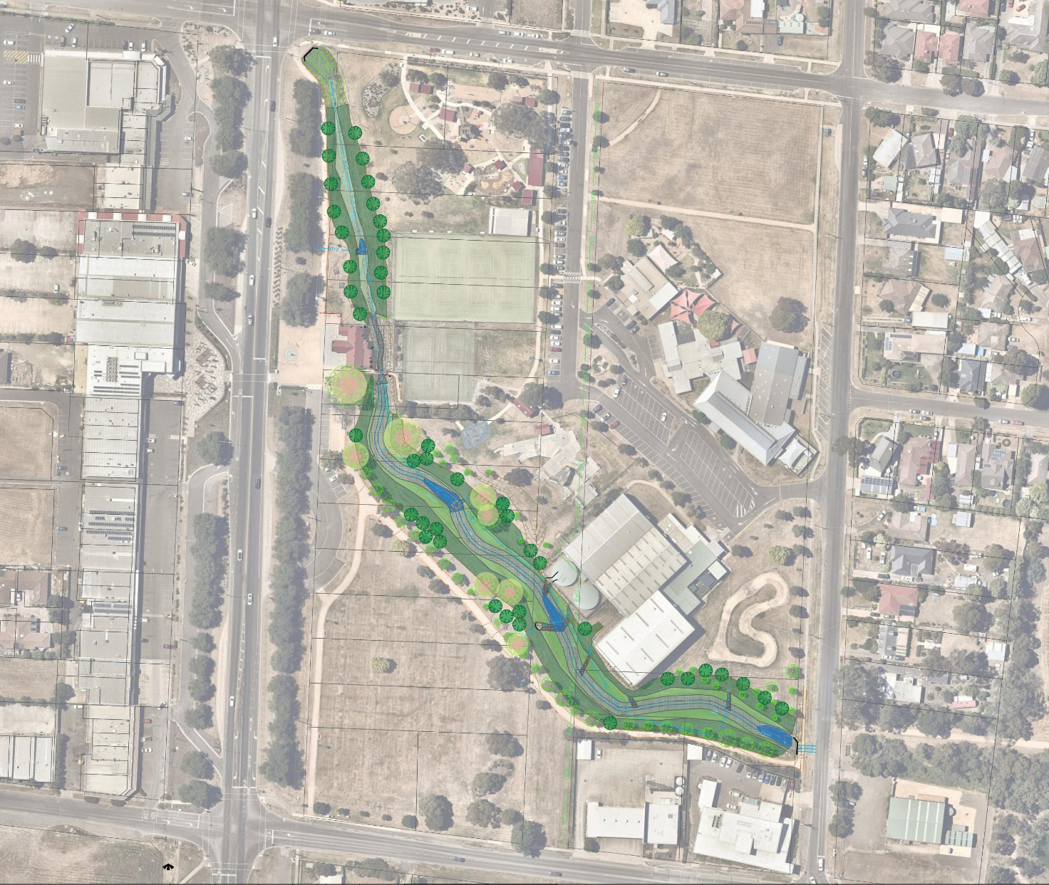

Melbourne Water is committed to delivering world-class solutions with minimal impact on the community, on businesses and on the environment.

|  |  |
| --- | --- |
| **Keep up to date with what’s happening**  For more information about this project or our other activities please call 131 722 or visit www.melbournewater.com  For an interpreter, please call the Translating and Interpreting Service (TIS National) on 13 14 50 | **Visit us**  www.melbournewater.com.au  **Like us**  facebook.com/melbournewater  **Follow us**  @MelbourneWater |