Community bulletin
Grasmere Creek Wetland creation

January 2020

Melbourne Water is committed to enhancing life and liveability in your area. To manage our asset and improve floodplain and ecological connectivity as well as increasing passive recreational opportunities, we will soon be undertaking works on Grasmere Creek, Berwick to create a new wetland area and realign the southern reach of Grasmere creek for the local community to enjoy.

Background
In 2016, Melbourne Water, Parks Victoria and the City of Casey came together to investigate the potential realignment of the southern reach of Grasmere Creek and the construction of an ephemeral stormwater treatment wetland system to service the existing catchment whilst providing future environmental and community benefits.

Creation of a new wetland
This 630 metre section of Grasmere Creek, upstream of Inglis Road, Berwick was previously channelised and is currently positioned under high voltage transmission lines. This positioning limits floodplain connectivity and any vegetation establishment or rehabilitation potential, as well as well as restricting passive recreation opportunities through the Cardinia Creek Parklands.
An existing wetland near the site provides one of the most significant populations of Dwarf Galaxias, an Environment Protection and Biodiversity Conservation Act 1999 (EPBC) listed species, in south east Melbourne. The project will also support the creation of drought habitat for this endangered fish species.
The renaturalisation of the waterway and creation of this new wetland will demonstrate several benefits and waterway outcomes for this reach of Grasmere Creek including:
- improved floodplain connectivity while supporting habitat for drought refuge species including Dwarf Galaxias.
- creation of an ephemeral stormwater treatment wetland which services the Grasmere Creek catchment as well as providing best practice water quality improvement, nitrogen and sediment removal from Westernport bay.
- enhanced wildlife corridors and cultural heritage features of the park aligns with Parks Victoria’s Masterplan.
- improved recreation and liveability benefits for the local community.
The project will enhance the wildlife corridor through the Cardinia Creek Parklands and will provide a shared path linking Inglis Road with Buchanan Road, Berwick for local residents and visitors to enjoy.

The Parklands also contains many significant cultural heritage features which the project aims to protect and commemorate.

Working collaboratively
This project is an example of a co-delivered collaborative program through partnered efforts involving the City of Casey and Parks Victoria. The City of Casey are providing in principle 40,000 plants towards on ground community planting day activities. In addition, Parks Victoria are providing Melbourne Water the land to implement the project.
As part of this project, there is opportunity for local community groups and schools to be
involved in planning for liveability aspects ‘place making’ of the project.

Interested community members are encouraged to get involved and to provide feedback.

Project design
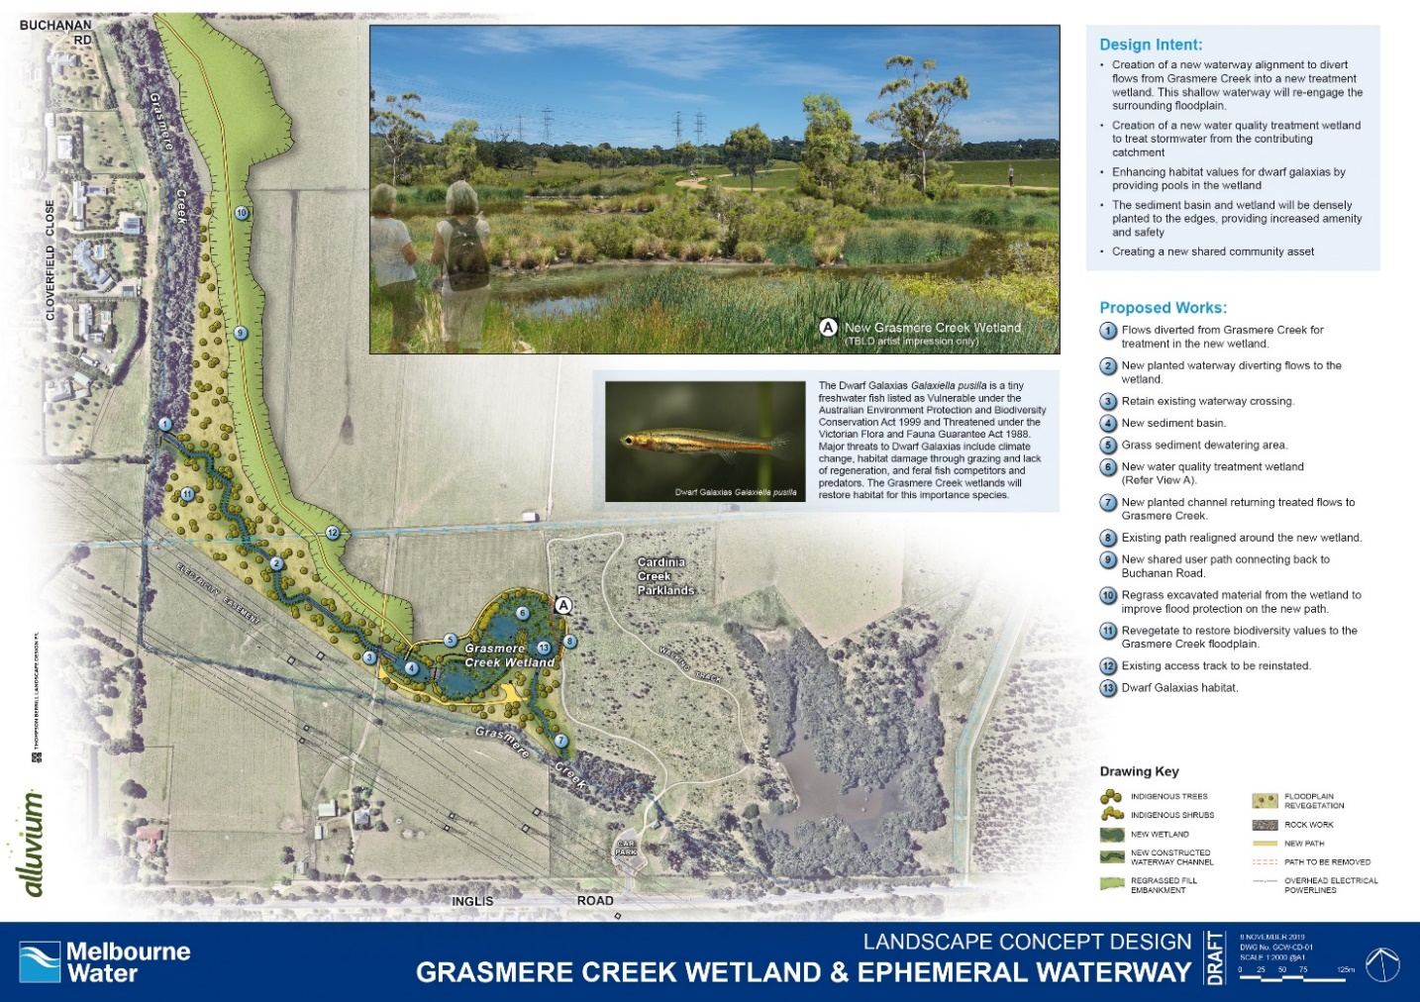

Timing of works
Works are due to commence in January 2020 with completion of the civil works by June 2020. Revegetation and planting of the wetland will be undertaken between March and June 2021.
For more information about this project or our other activities please call 131 722 or visit www.melbournewater.com
For an interpreter, please call the Translating and Interpreting Service (TIS National) on 13 14 50

