Sunbury’s Water Future

Water management planning for the Sunbury region

Challenges for the Sunbury region: Population growth and climate change impacts
The effects of a changing climate, growing population and increasing urban development will impact the available water sources in the Sunbury region as well as our local waterways.

Why is the population growing?
Sunbury has been identified as an area of growth by the Victorian State Government. The population is forecast to more than double over the next 20 years.
The Victorian Planning Authority has set out a plan for Sunbury. It outlines a clear vision for housing, transport, employment, open space, shopping and community services to support this growth.
Population growth increases water demand and will produce greater volumes of wastewater and stormwater to be managed.
Growth Corridor Plans: https://vpa.vic.gov.au/greenfield/growth-corridor-plans/

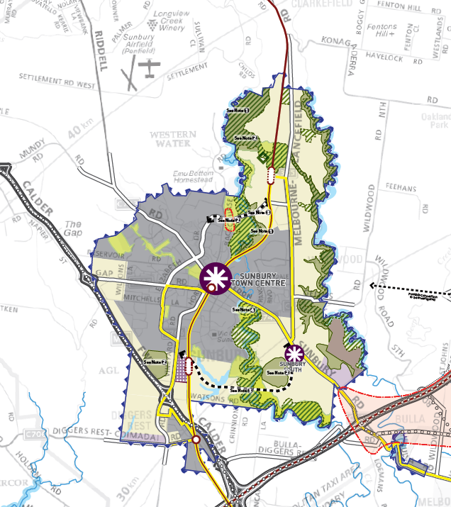

What are the impacts of climate change?
Greenhouse gases like carbon dioxide in the Earth’s atmosphere play a key role in making our planet warm enough to support animal and plant life. But, these gases have been increasing since the mid-1800s, causing our climate to change.
This is a major issue for our water supplies as it will cause:
- higher average and minimum temperatures
- more storms, bushfires and heatwaves
- less rainfall
- more frequent and intense heavy downpours
- rising sea level
As well as the impacts of climate change, Melbourne’s weather has always been variable. We’ve had long periods of low rainfall causing droughts and periods of high rainfall causing floods.
The harsh Millennium Drought (1997 to 2009) followed the wet decades of the 1950s and 1970s. It had an extreme impact locally as our water storages almost dried up.
Western Water acted quickly to construct pipelines that connected local towns to Melbourne’s water supply system. This helped to meet immediate water needs but we need to identify additional water sources to make up for gaps in water availability caused by climate change and population growth.

Climate change and our local waterways
Climate change remains a threat to water supplies and the environment across Melbourne. More drought and heatwave events are predicted, with less overall rainfall and an increase in extreme events like storms and floods.
When our waterways are exposed to increased stormwater, this leads to poorer water quality and erosion, among other impacts.
Over the longer term, climate change will affect the habitat of plants and animals that live along waterways and around wetlands.

