Sunbury’s Water Future

Water management planning for the Sunbury region

Water management in the Sunbury region: Local water sources and uses
As the population grows, there’s increasing pressure on our drinking water supplies. There’s also increased potential to capture and produce alternative water for reuse.

Where does the Sunbury region’s drinking water come from?
Drinking water for the Sunbury region comes from the local Rosslynne Reservoir and the Melbourne Water supply system. The supply from Rosslynne Reservoir is limited and has reduced over time due to lower water flow into the reservoir.

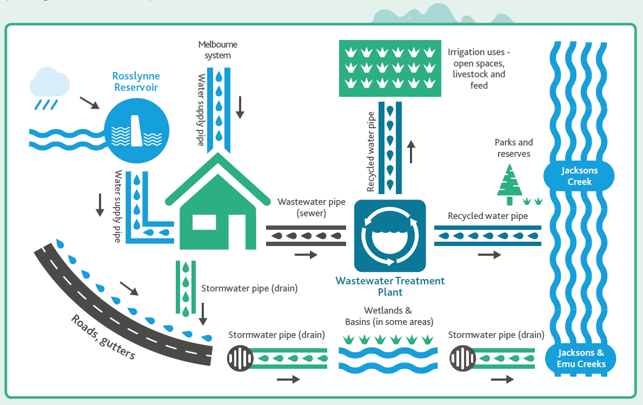

What’s the difference between stormwater, wastewater and recycled water?
Rainfall that runs off roofs, roads and other hard surfaces into gutters, drains, creeks and rivers, and eventually into the sea is called ‘stormwater’. In new growth areas, wetlands and basins are constructed to help filter stormwater.
Water that’s been used in the home, in a business or an industrial process is called ‘wastewater’. It’s captured in different pipes to stormwater.
When wastewater goes through a treatment process, it becomes ‘recycled water’ that can be reused for other purposes. The Sunbury Recycled Water Plant is one of seven recycled water plants operated by Western Water.
Recycled water can have different levels of treatment depending on what it is to be reused for. Recycled water is also released to waterways.
Western Water’s approach to recycled water: http://www.westernwater.com.au/Our-Services/Recycled-Water

